
St Elisabeth’s CE Primary School News
Friday 21st November 2025
Belonging, Believing, Becoming.
‘To grow a diverse and creative educational community, where we encourage belonging and nurture believing; together becoming fulfilled and responsible members of God’s world.’
Address: St Elisabeth’s Way, Reddish, Stockport. SK5 6BL.
Tel: 0161 432 5785
e-mail: office@thrive-ste.com
website: www.thrive-ste.com

Dear Parent/Carer,

I would like to start by saying a big ‘thank you’ to all of you who have contributed to our ‘colour’ hampers for the Christmas Raffle. The final day for donations is next Friday 28th, and the following week we will send you photographs of the completed hampers and the raffle tickets will go on sale.

Year 1 had a fabulous ‘toy’ workshop on Thursday where they learnt about toys from the past – the children really enjoyed their experience.

Let’s hope the weather thaws over the weekend.

Best wishes

Mrs Lancashire

Kind regards

Mrs Burrows

Lower Key Stage Two
This week in R.E., Year 3 have been looking at how Christians interpret God’s Message shared in Genesis in the Creation Story. Over the last three weeks, we have looked at this story in depth and considered how giving environmentally friendly gifts and using recyclable wrapping paper and tape can help look after the planet. Year 4 are looking at Hinduism and by learning about a different faith, the children are beginning to draw comparisons between Hinduism and Christianity. This Banyan Tree represents Sanatana Dharma – the eternal way.
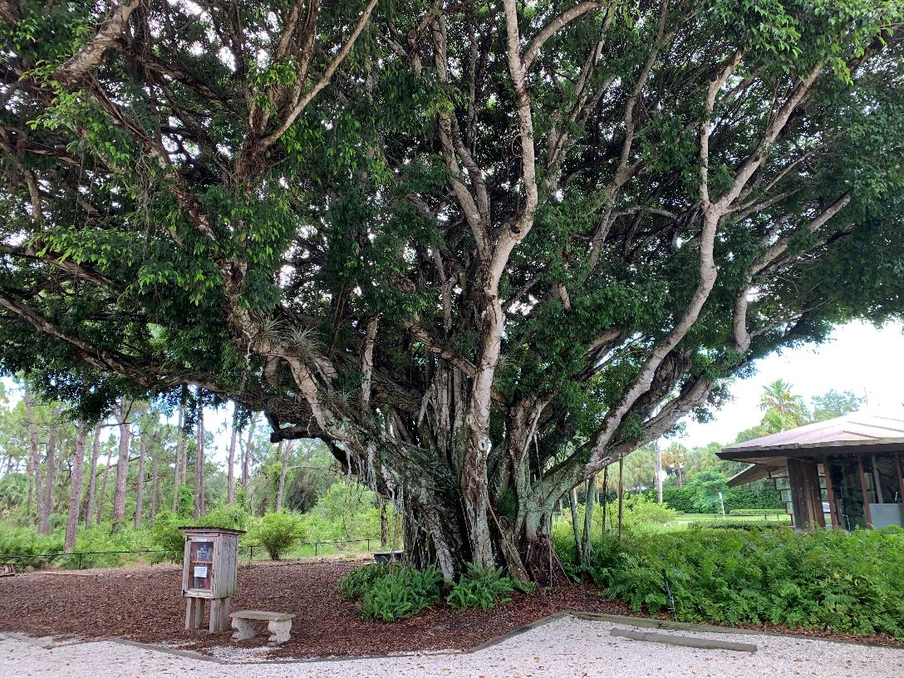

Key Stage One
Key Stage 1 have been working hard rehearsing for the Nativity, singing beautifully and projecting their voices with confidence. Their enthusiasm shines through every practice, as they learn their lines, perfect their songs, and bring the story to life with joy and energy. It’s wonderful to see their pride growing with each rehearsal.
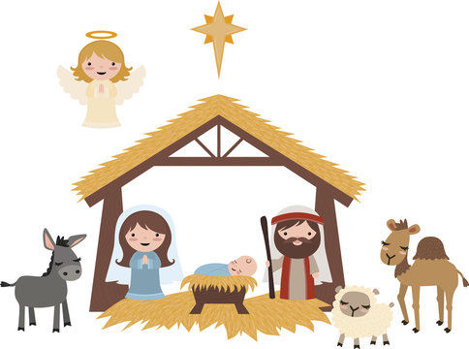

EYFS
The children in Reception and Nursery have been producing fantastic pictures and writing in drawing club this week. We opened our story, The Colour Monster, to find that lots of the emotions had been stolen from the pages! The children have created wonderful, imaginative ideas of what the emotion thief looks like and spent time drawing their ideas. Reception have worked hard to apply their phonics knowledge to write a password that makes their pictures come to life and catch the thief!
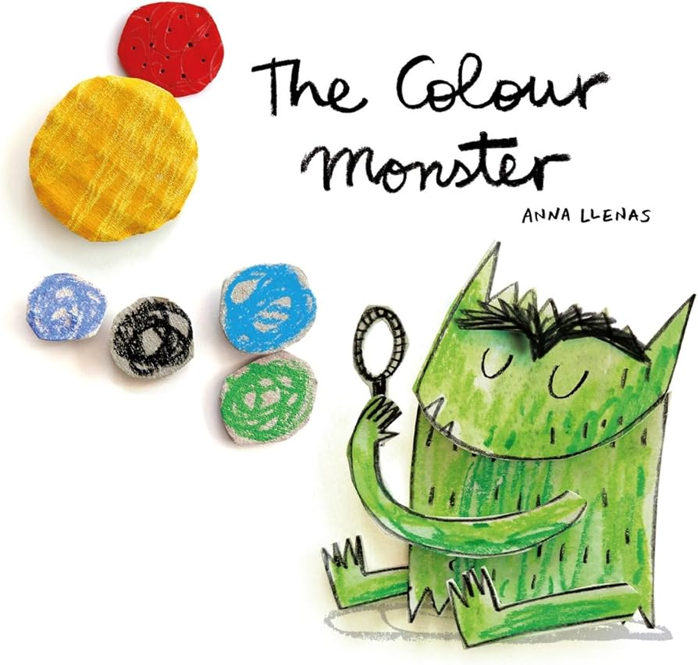

[Grab your reader’s attention with a great quote from the document or use this space to emphasize a key point. To place this text box anywhere on the page, just drag it.]

Ensuring Excellent Attendance for All

Nursery all day - 100%



Year 4 – 97%

Well done!

Upper Key Stage 2
This week, Upper Key stage 2 have been carrying out scientific investigations to investigate if adding another cell to a circuit would make a bulb brighter or a buzzer louder. With our partner we planned our investigation, ensuring that we were carrying out a fair test and identifying our variable. Following our plan, we created a simple circuit and tested our predictions. We found that adding another cell to a circuit does increase the brightness of a bulb and the loudness of a buzzer.
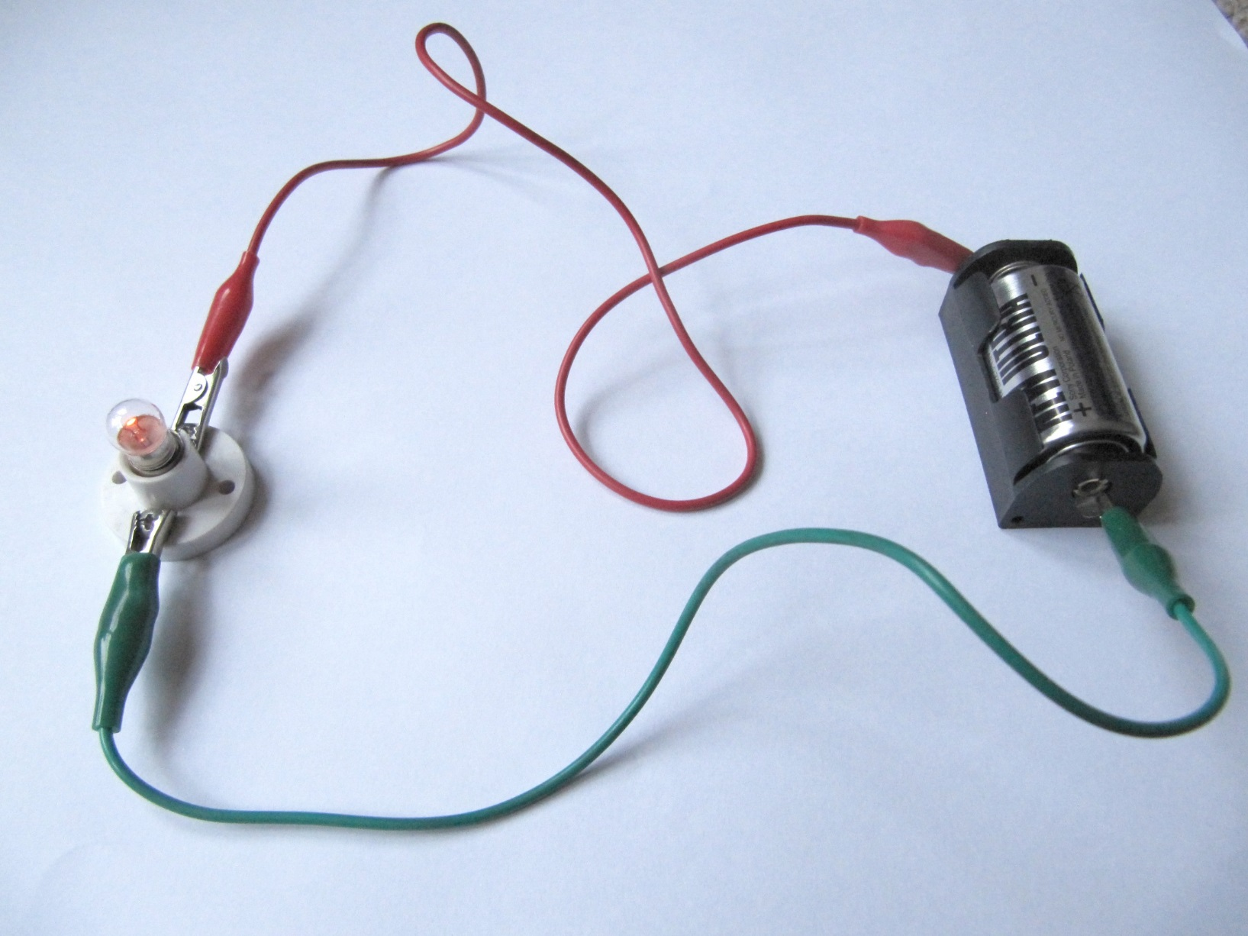

BIRTHDAYS

Happy Birthday
To

Bella

Olivia

Have a lovely day!

s
This week the theme in Collective Worship has been ‘Thankfulness’. We have been thinking about who helps us and who we need to be thankful for like the NHS, our parents and our teachers.

BIRTHDAYS
(2.9.21 – 12.9.21)


Have a lovely day!
Oscar
Emma
Amber
Thea
Jacob
Mariah
Cainan
Olivia
Gospel
Corbin
Toby



ATTENDANCE
SUPERSTARS
N | Zoha, Ariella, Haider, Nael, Emily, Lillie, Willow and George
R | Amyra, Jad, Luca, Jaida, Namia, Eric, Renesmae, Jaycee, Allayah, Jana, Jorgina, Jack, Teddie, Junior, Archer, Nola, Truly, Aidhen, Muhammad, Zohan, Bella and Bleu
Year  1 | Ariya, Aniyah, Rion, Olivia, Xayn, Hollie-Rose, Mylamae, Maisie, Tommy, Olivia, Bitanya, Maisie, Adalina, Harper-Leigh, Toby, Yannis, Emmy, Jaden, Kendall and Ridah
Year 2 | Max, Ismail, Farid, Sidney, Bobby, Ahmed, Lillie-Ann, Nathan, Priestly, Ebenezer, Dominic, Grayson, Reyan and Future
Year 3 | Mayez, Naomi, Olivia, Penelope, Mia, Bella, Xander, Luca, Oliver, Sairah, Leo, Skylar, Bella, Ralphie, Musa, Oscar, Farah, Ava, Arlia and Lila
Year 4 | Uthman, Anayah, Leo, Aria, Muktar, Joseph, Charleigh-Anne, Emelia, Archie, Kylan, Vinnie, William, Willow, Sionna, Solomon, Elsie-Rose, Remiah, Meadow, Miley-Mae, Evie, Isabella, Thea, Emma, Abdullah, Amber, Jenson, Jaxson, Arthur and Taylan-Joel
Year 5 | Jacob, Quinn, Zain, Leo, Matilda, Heidi, Harper, Lottie, Lucy, Jaxon, Amelia-Rose, Rosie, Reggie, Rose, Willow, Ayub, Ethan, Chloe and Emily
Year 5/6 | Amber, Zak, Aisha, Rahmatullah, Jamie, Emily, Freddie, Jacob, Olivia, Amirah, Ava-Grace, Aleena, Harrison, Layton, Ephraim, Keira, Harry, Louie, Daisy and Ayaan
Year 6 | Tayyba, Jasmine, Jackson, Finley, Mason, Luisa, Natalia, Colin, Finn, Max, Amelia, Sienna, Madison, Aurora, Leon, Noah, Maisie, James, Cainan, Phoebe, Harry and Thomas



